To Members of Austrey Parish Council
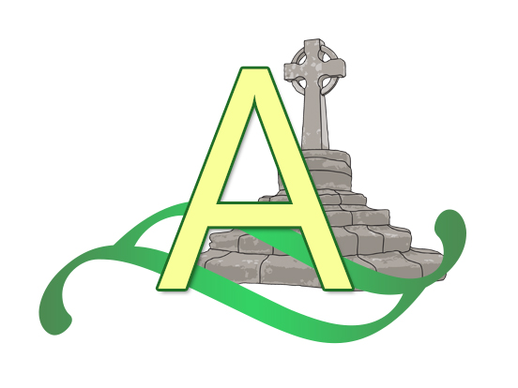
You are hereby summoned to attend the meeting of Austrey Parish Council.
To be held at 7.30pm at Austrey Village Hall on Wednesday 7th February 2024.
Members of the press & public are welcome to attend.
Agenda:

- Present/Apologies for absence.

- Declarations of interest. For councillors to disclose any financial, personal, or other interests which have a bearing on their role on the Parish Council.

- Minutes: to approve minutes of the last parish council meeting which took place on 10th January 2024.

- Open Forum- Parishioners are invited to address the council on any relevant matter for a maximum of three minutes per person.

- Clerk’s Update.

- Discussions & updates on recent or regular items:

  - Austrey Emergency Plan & flooding
  - Neighbourhood Plan
  - Playing Fields
  - Village Maintenance
  - Village Speed Limits

- Planning: to consider recent applications and decisions.
- Applications: No new applications since the last meeting.
- Determined: PAP/2023/0482 - 12, Mill View Gardens, Austrey, CV9 3FD
Change of use of land from agriculture to equestrian, proposed mobile shelter on skids for ponies and erection of a building for the use of storage, machinery and vehicles. GRANTED

- Correspondence

- Financial Matters: to consider payments to be made, expected bills etc.

- Councillors’ matters & items for future agenda: this is the opportunity to report minor matters of information not elsewhere included on the agenda, to discuss action points & to raise issues for future agendas.

- Date of next meeting: confirm next meeting which is scheduled for 13th March 2024

Lynsey Treadwell
Clerk to Austrey Parish Council
02/02/2024

